Given a 2D grid of size n * m and an integer k. You need to shift the grid k times.

In one shift operation:

* Element at grid[i][j] becomes at grid[i][j + 1].
* Element at grid[i][m - 1] becomes at grid[i + 1][0].
* Element at grid[n - 1][m - 1] becomes at grid[0][0].

Return the *2D grid* after applying shift operation k times.

**Example 1:**

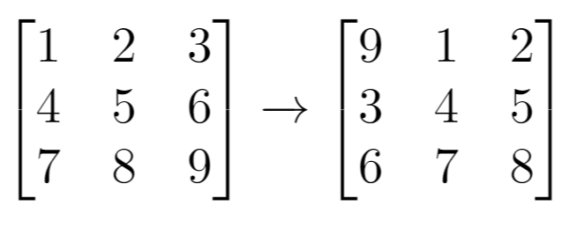

**Input:** grid = [[1,2,3],[4,5,6],[7,8,9]], k = 1

**Output:** [[9,1,2],[3,4,5],[6,7,8]]

**Example 2:**

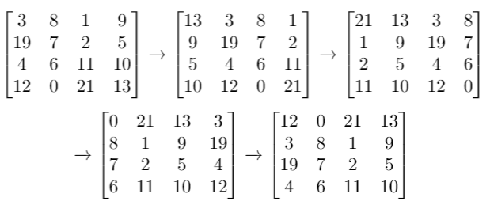

**Input:** grid = [[3,8,1,9],[19,7,2,5],[4,6,11,10],[12,0,21,13]], k = 4

**Output:** [[12,0,21,13],[3,8,1,9],[19,7,2,5],[4,6,11,10]]

**Example 3:**

**Input:** grid = [[1,2,3],[4,5,6],[7,8,9]], k = 9

**Output:** [[1,2,3],[4,5,6],[7,8,9]]

**Constraints:**

* 1 <= grid.length <= 50
* 1 <= grid[i].length <= 50
* -1000 <= grid[i][j] <= 1000
* 0 <= k <= 100